

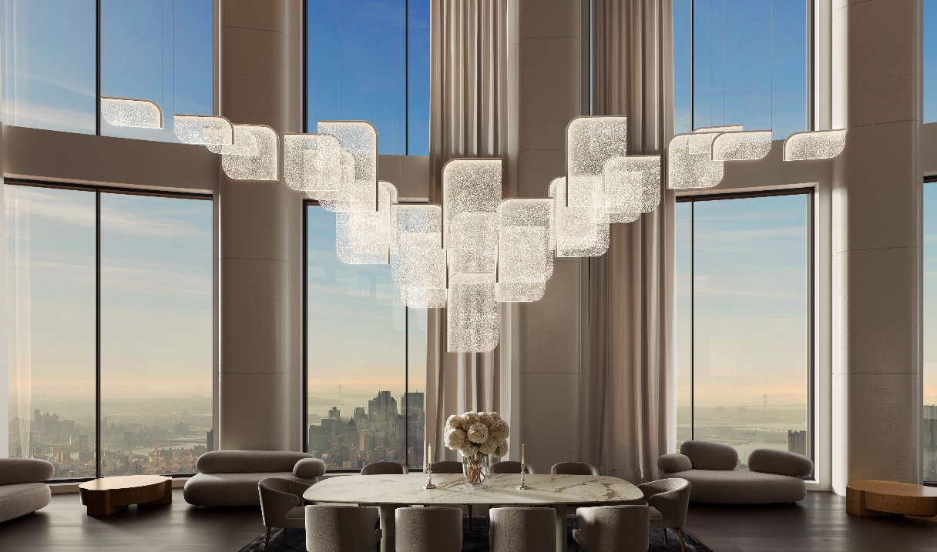

Preciosa Lighting unveils Drifting Lights

A new Signature Design capturing the quiet poetry
of light suspended in glass

Preciosa Lighting, the Czech brand renowned for elevating traditional glassmaking through contemporary design and cutting-edge technology, introduces its latest Signature Design: Drifting Lights. Debuting at Downtown Dubai Design 2025, Drifting Lights celebrates light as a living presence—captured, guided, and set into motion within crystal-clear fused glass.

Where Light Lingers Like Memory
The beauty of Drifting Lights lies within: fragile worlds suspended in glass, where light does not simply reflect but lingers like a beautiful echo from the past.

Tiny bubbles drift inside the material like silent carriers that guide and bend the light, holding on to its memory. This transforms stillness into movement, turning each piece into a quiet constellation. Natural alchemy during the fusion of glass sheets evokes the formation of air bubbles, creating a living canvas of light. Crisp, aligned glass panels, suspended within a steel silhouette, are illuminated with static or dynamic lighting that brings their subtle inner worlds to life.

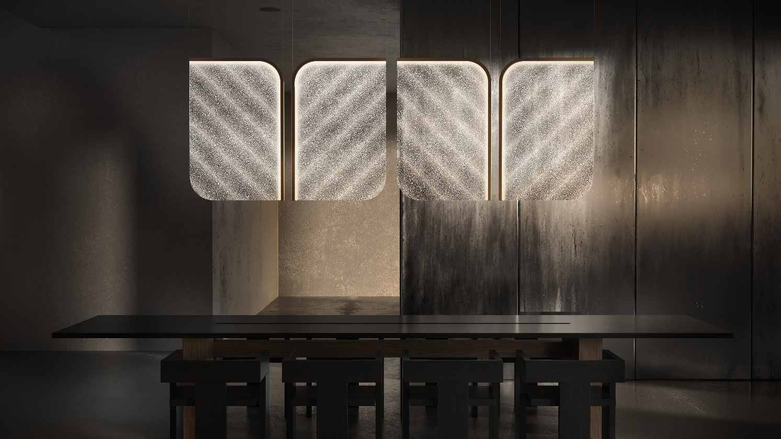

A Contemporary Expression of Purity and Craft
The design centers on crystal-clear fused glass panels, each encased within a slender stainless-steel frame. Through a precisely controlled technique, delicate air bubbles form harmonious pockets in the material, giving every panel its own quiet topography. As light passes through, it flows like liquid, casting emotive, ever-changing scenes that captivate the senses.

Panels are available in ten distinctive sizes and may be arranged vertically or horizontally, offering designers the freedom to create compositions ranging from subtle to sculptural.

Layers of Artistry
The bubbled glass panels at the core of the design may be enhanced with the optional Fused Veil pattern, offered in Vortex or Diagonal motifs. This artistic layer introduces gentle pigment movements within the glass—soft gestures that shimmer with passing light and subtly deepen its diffusion.
For projects requiring an even more distinctive expression, the panels can be enriched with a unique painting technique applied between the fused layers. This delicate touch transforms pigment into floating, luminous traces inside the glass, adding a personalized signature to each composition.
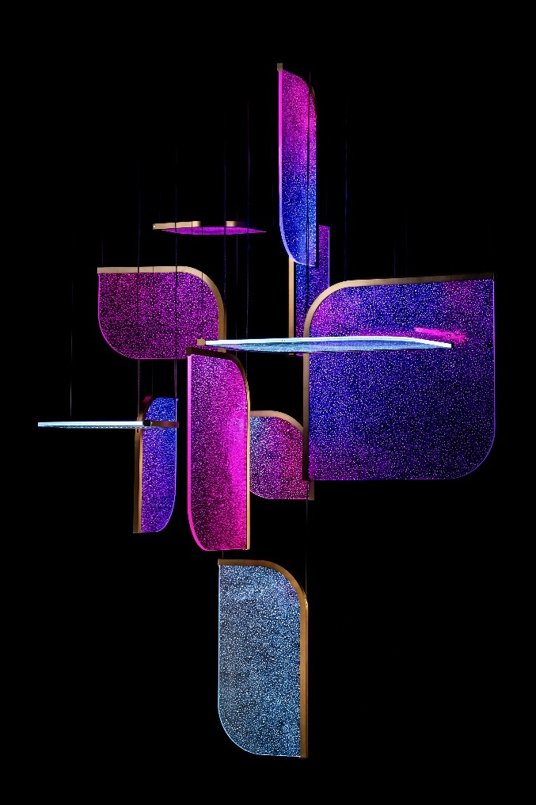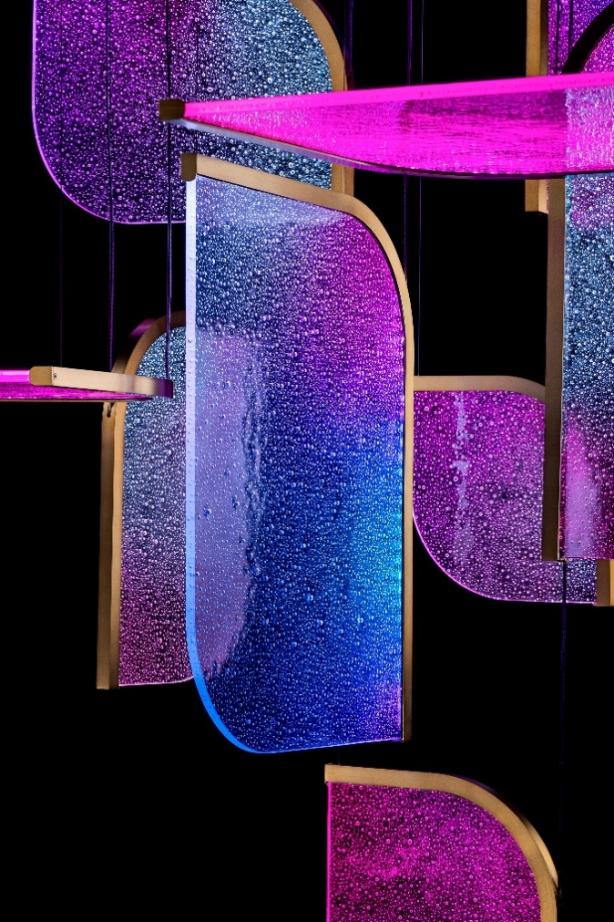

Light as Movement
Injected light is at the heart of Drifting Lights. Concealed LED strips channel illumination directly into the edges of each panel, creating a seamless inner glow. As the light travels through the glass and refracts through the air and pigment bubbles, it takes on a liquid-like quality—diffusing, drifting, settling.

While Drifting Lights emits a quiet glow under static illumination, it truly comes alive with dynamic scenes. Using 3D spatial mapping and RGBW technology, designers can choreograph fluid movements of light across the suspended panels, transforming spaces from calm to vibrant.

Signature Designs
Drifting Lights is the latest addition to Preciosa’s Signature Designs portfolio, comprising a curated selection of lighting solutions that can be fully customized for unique compositions. Signature Designs are available to Preciosa’s clients in scales, colors, materials, surface finishes, construction principles, and illumination methods tailored to their individual briefs—and crafted to exceed expectations.

About Preciosa Lighting
Preciosa elevates the heritage of Bohemian crystal through contemporary lighting design. The company is built on three centuries of tradition and the unique art of master glassmakers from Crystal Valley. Preciosa honors this heritage and craftsmanship by creating innovative lighting products that stand the test of time.

Media Contact:
Barbora Jankovská
Marketing Communications Specialist
barbora.jankovska2@preciosa.com
+420 739 520 778

